Name: ___________________

Political and Physical Features of Latin America

**Part One:** Use a pen to label the following nine countries on the map:

* Chile
* Brazil
* Colombia
* Cuba
* Haiti
* Mexico
* Panama
* Venezuela
* Peru
* Bolivia

Next, use a marker to **outline the** **political border** of each country.

__________________________________________________________________________________________

**Part Two:** Use a pen to label the following eight physical features on the map:

* Amazon River
* Caribbean Sea
* Gulf of Mexico
* Pacific Ocean
* Panama Canal
* Andes Mountains
* Sierra Madre Mountains
* Atacama Desert

1. Color the Pacific Ocean, Amazon River, and the Gulf of Mexico **DARK BLUE**.

2. Color the Caribbean Sea **LIGHT BLUE (or TEAL).**

3. Draw a **RED** box where the Panama Canal is located.

4. Draw triangle symbols around the Andes Mountains and color them **GREEN**.

5. Draw triangle symbols around the Sierra Madre Mountains and color them **YELLOW.**

6. Color the Atacama Desert **BROWN.**

C:\Documents and Settings\e200602727\Local Settings\Temporary Internet Files\Content.IE5\MQB77Q72\MCj02336510000[1].wmf

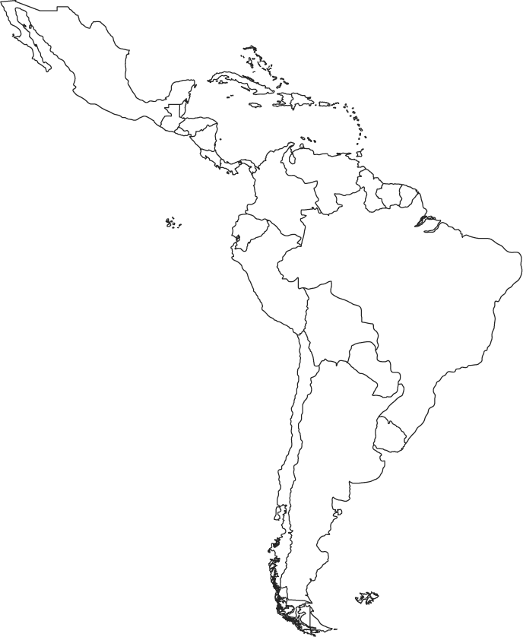

Latin America