**SOCIAL STUDIES FAIR 2014**

**GROUP MEMBER NAMES (1 packet per group)**

1.

2. (SS teacher_____________)

3. (SS teacher_____________)

*Students participating in the Social Studies fair will…*

1. Select an appropriate Social Studies topic.
2. Formulate an appropriate research question.
3. Conduct research (some original, when appropriate) to find an answer to your question.
4. Analyze the data.
5. Write a research paper (4-5 page, typed double spaced, times new roman, MLA style)
6. Create a visual display that includes graphs, pictures, surveys, etc.
7. Prepare an abstract (on a 5x7 notecard)
8. Prepare for a short interview about the purpose and conclusions of your project.

*Social Studies Fair Due Dates*

TOPIC SELECTION August – September

TOPIC & QUESTION DUE October 1

METHODOLOGY (Procedures) DUE October 7

NOTES & OUTLINE DUE October 21

RESEARCH PAPER – 1st DRAFT DUE October 31

BACKBOARD SKETCH DUE November 6

FINAL PROJECT (Paper, Board, Abstract) DUE November 18

SUTTON ALL FAIR December 1 – 5 Community Hall

1. **Select your topic -** Select a topic that really interests you. Here is a list of possible Social Studies Fair topics, many of which are hot current events topics that you may be discussing in your Social Studies class right now.

Stand Your Ground Law

Cyber Bullying

War in Afghanistan

Syria’s Civil War

The Sudan / South Sudan Conflict

North Korea’s Totalitarian State

South Africa after Apartheid

Iran’s Nuclear Program

China & Human Rights

Chief Justice Sotomayor

President Obama

Online Privacy

Hacking

Shou

Fast Food Workers strike for $15 per hour

Ukraine

Affirmative Action

Drones

GA Gun Laws

Women’s Rights in the Muslim World

Equal Pay for Women in the USA

Deportation in America

Mexican Drug Cartels

Female Genital Mutilation

Terrorism Locked up Congress in America

Immigration

Shooting Death of Michael Brown

Ebola

ISIS – Iraq

New Football Stadium for the Falcons

New Baseball Stadium for the Braves

Gay Marriage

Marijuana Legalization

Paying College Athletes

Malala Yousafzai’s & Women’s Education

Texting While Driving

Fracking for Natural Gas

Cyber Warfare

Climate Change

Make a list of things from the above list (or not from the list) that interest you most about social studies… ____________________________________________________________________________________________________________________________________________________________________________________________________________________________________________________________________________________________________________________________________________________________________________________________

**TOPIC GOTCHAS**

1. Avoid topics that are limited.
   1. Example: What crops are grown in our county?
   2. A student cannot write a report on a topic that can be explained in a few words or a sentence.
   3. Better topic: What is the economic impact of peanut production in our county?
2. Avoid topics that are too broad.
   1. Example: What happened during the Civil War?
   2. Topics which are too big make it impossible to find all the information that is needed to cover the topic adequately.
   3. Better Topic: The Role of (name of a local historical figure, place or event) in the Civil War.
3. Research the topic from a social studies viewpoint rather than investigating it as a natural science topic.
   1. Example: Nuclear power as a political issue rather than "how it works”
   2. “How it Works” would be a Science Fair Project. If Science interests you do a Science Fair Project

**TOPIC APPROVAL SECTION: The topic I (we) have chosen is… __________________________________________________________________________________________________________________________________________________________ *Teacher Initials: _______***

1. **Formulate an appropriate Research Question –** Coming up with the right question is the first step of any research process. As you narrow down your topic by reading about it, you will begin to have questions that seem important to you. Everything in your paper and on the project board will relate to the answer to the question. So your question needs to be good before you move forward with your research.

Why have the Kurds never gotten a country of their own? Why do the Palestinians and Jews keep fighting in Israel? These are questions that could make great Social Studies projects. Maybe you have a strong interest in cooking and you’ve love learning about different styles of food. Have you ever thought about looking into what makes Indian food Indian? Or, maybe “Civil Rights” is your thing. What impact has the shooting death of Michael Brown in Ferguson, MO had on American law enforcement?

* 1. On a separate sheet of paper, list ten questions that deal with your topic. Ask each of these questions about your possible research questions:
     1. Is the topic relevant? Will the answer be of any benefit to you or your community? Ask “so what?” about the question.
     2. Did you avoid questions with “yes” or “no” answers?
     3. Do you already know the answer to the question? (avoid)
     4. Are you biased or prejudiced about the topic?
     5. Will you be able to draw some kind of conclusion to the question?
     6. Can you find information in your community on the topic?
     7. Can you do original research on the topic? (preferable)
  2. Narrow your list of questions to three & discuss the questions with parents, teachers, and friends.
  3. Choose the best research question.

**QUESTION APPROVAL SECTION: The question I (we) have chosen is… __________________________________________________________________________________________________________________________________________________________ *Teacher Initials: _______***

1. **Establish your Methodology -** Methodology includes the steps in gathering, analyzing, and interpreting the data used to answer your research question. Methodology should include a variety of resources. *One method of research must be original. (Survey, Interview, etc).* Your methodology does not include the steps you take in writing the paper or constructing the display. Your research methodology must be reported in the paper and on the project board.

BELOW IS A SAMPLE METHODOLOGY



1. **Collect, Analyze and Interpret the Data -** Gather articles about your research question. Go to GALILEO and find articles that will help you find answers. Read the articles and think about what they say. Annotate the articles. You should discover information that leads you to more articles. Take notes and make an outline that leads to a conclusion. Charts, tables and other graphic organizers may be used to record information in a form that clarifies how you reach your conclusion (answer to the question). Use critical thinking processes to interpret the data and make inferences that lead to a conclusion. Here is how you can find an article on your topic AND save the Bibliography info at the same time. USE GALILEO in SUTTON HELPFUL WEBSITES
   * 1. The 4th helpful website link is “Galileo”. The password (8-21-14) for Galileo is… \***reptile**\*
     2. Click on “Teen grades 6-8”
     3. Click on “Social Studies”
     4. Mrs. Marsh’s very favorite DATABASE is called **SIRS DISCOVERER**
     5. **Type in “IRAN” (or whatever your topic is) in the search box**
     6. **877 articles on IRAN (SIRS cuts to the chase, gives you articles that are “reliable”)**
     7. **Click on and article and read to see if you think it will help you answer your question.**
     8. **Take notes on your article. Write down the title of the article and the author.**
     9. **Now let’s “Cite” the information of this article (so that when we write a paper, readers will know where the information came from**
     10. **SCROLL TO BOTTOM where there is a box that says “Citation”**
     11. **Copy the information to the right of MLA (the MLA is on letter on top of the other) This is the authors name, article title, publication, volume, data base, date etc.**
     12. **Paste this “citation” somewhere (email, word doc, mybackpack doc) and save it**
     13. **You have now “collected” and “analyzed” and “Cited” a resource.** Plus, you have also started your bibliography using MLA style. How cool is that?!!
     14. **Don’t forget to save the article by emailing it to yourself.**
2. **Write the Summary Paper –** When a sufficient amount of information to reach a conclusion has been analyzed and interpreted, the student should write a draft of the research paper. Your paper should be 4 to 5 typed, double-spaced pages using Times New Roman font. It should also include a title page with credits, the paper itself, a bibliography, and a credits page. It should be neatly bound in a folder. The main purpose of your paper is to use facts gained from research to answer your question. These facts should be in your own words and should not be copied from any of your sources. Any idea that is not your own should be properly “cited.”
3. **Title Page/ Cover Page -** The title/cover page should be bound in a folder which clearly presents the name of the project, student name, school name, grade level, and the name of your teacher.
4. **Verification & Credit Page -** The credit page will include the names of people who helped you with your project. This can include names of your family members, along with anyone you talked to about your topic. The credit page should be in complete sentences in a paragraph form. You must also state how each person helped you. A list of names will not be accepted. Also, if your paper was typed by anyone other than yourself, you must include the following at the bottom of your credits page.



1. **Body of Paper** (4-5 double-spaced typed pages)
   * 1. The **Statement of the research question/problem being explored** clearly states why the research topic was chosen.
     2. The **Methodology** explains the steps in the research process—how data was systematically collected and analyzed.
     3. The **Research findings** include adequate and balanced information in a sequential and convincing manner. Include the facts you found and information in a logical order that explains your research findings. Any idea that is not your own should be properly cited.
     4. The **Conclusion** presents a summary of the key idea and answers the question being explored. Your conclusion should be a paragraph (or paragraphs) that include facts from your research and it should be at the end of your paper. You will also need a separate copy of just the conclusion for your backboard.
2. **Bibliography** - A bibliography page is a list of the resources you used in order to complete your research paper. You must have at least 3 sources and only one may be an encyclopedia. Arrange the list of resources into ABC order according to the author’s last name. If the author is unknown, use the name of the book or title of the article.
3. **Write the Abstract** - the Abstract should be written on an index card after the paper is completed, will be given to the judges by the student to use as an overview at the beginning of the interview. Information on the abstract provides a succinct description of the project, including the title, statement of problem or question, methodology, and conclusion. 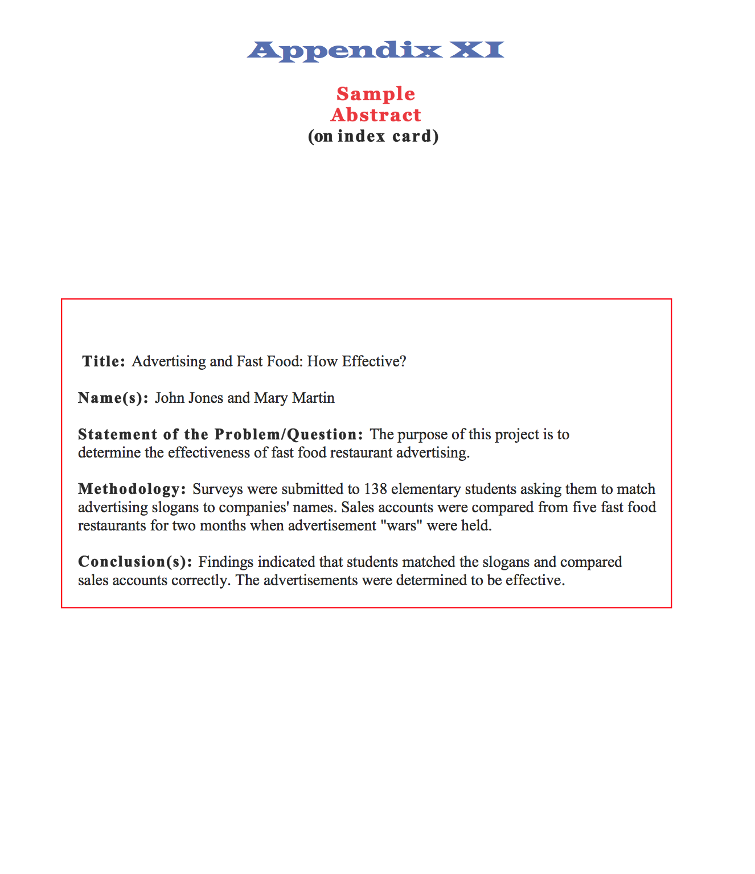
4. **Construct the Visual Presentation –** Here is a sketch of what your board could look like…

TITLE: CAN BE IN QUESTION FORM

CONCLUSION(S)

VISUALS: Organize photos, graphs and tables carefully to ensure that only data relevant to answering your question is shown.

PURPOSE

The exact same conclusion from your paper needs to be on this side of your project. This is the ONLY part of your paper you put on the project board.

All Headings like “Purpose” “Methodology” and “Conclusions” should be BIG BIG BIG so that they stand out.

METHODOLOGY

VISUALS: Organize photos, graphs and tables carefully to ensure that only data relevant to answering your question is shown.

VISUALS: Organize photos, graphs and tables carefully to ensure that only data relevant to answering your question is shown.

VISUALS: Organize photos, graphs and tables carefully to ensure that only data relevant to answering your question is shown.

(ABSTRACT)

Paper

(in Folder)

(Include Visuals that illustrate or enhance the research findings) Avoid materials that do not relate to the answer to the research question.

**PURPOSE** (the purpose should be a short paragraph explaining your reason or reasons for doing your project)

____________________________________________________________________________________________________________________________________________________________________________________________________________________________________________________________________________________________________________________________________________________________________________________________________________________________________________________________________________________________________________________________________________________________________________________________________________

Teachers and other adults talented in visual display development may be enlisted to coach students in developing the best layout for their information. It is a good idea to have students submit a draft of their proposed layout for suggestions before beginning to work on the display and to check the use of space before attaching any items to the board. If models are used in the display, they should be student designed and constructed, rather than commercially prepared.

1. **Prepare for the Interview -** Students may prepare for the interview by having teachers or parents practice with them. Students should be able to give a brief overview of the development of their project and should be prepared to answer questions about importance of their research question/problem, methodology, sources, research findings, and conclusion. Often judges will ask students to explain their reasons for choosing the topic, to evaluate their work (suggest what might be done differently or additionally if the student were to do the project again), or to recommend what next steps could or should be taken regarding the topic.