**SMS SOCIAL STUDIES FAIR GUIDE 2016-2017**

Group Members (1 packet per group)

Name: __________________ SS Teacher: _____________

Name: __________________ SS Teacher: _____________

***Students participating in the Social Studies fair will…***

1. Select an appropriate Social Studies topic from the list below.
2. Formulate an appropriate research question.
3. Conduct research (some original, when appropriate) to find an answer to your question.
4. Analyze the data. (Take notes and create an outline for your paper)
5. Write a research paper (4-5 page, typed double spaced, times new roman, MLA style)
6. Create a visual display that includes graphs, pictures, surveys, etc.
7. Prepare an abstract (on a 5 X 7 notecard)
8. Prepare for a short interview about the purpose and conclusions of your project.

***Social Studies Fair Due Dates***

TOPIC & QUESTION DUE October 6th

NOTES & OUTLINE DUE (Early Bird) October 26th  OR (Late Bird) November 2nd

METHODOLOGY (Procedures) DUE (Early Bird) October 26th  OR (Late Bird) November 2nd

RESEARCH PAPER – 1st DRAFT DUE November 9th

BACKBOARD SKETCH DUE November 9th

FINAL PROJECT (Paper, Board, Abstract) DUE November 15th

SUTTON ALL FAIR December 2nd

***TOPICS***

|  |  |  |
| --- | --- | --- |
| **History**  History encompasses all that has happened to humanity. History, in a narrower sense, can be limited to the history of a country (all that has happened in that country), or it can be limited to a group of people, and institution, a community, etc. History is more than a systematic record of events of the past, because it usually includes analysis and explanation of these events. History is the record of changes of civilization | **Political Science**  Political science is the scientific study of the theory and practice of humanity in organizing and controlling the power necessary for group living. Different societies have different methods of human control. The process of government can be studied by description, through comparison and classification of political data. Political science includes the art, science, and philosophy of the governmental process | **Sociology/Psychology**  Group living is the result of humanity's social needs and necessitates cooperation within and between groups. Groups are constantly changing in nature and functions because personality, attitudes, motivation, and behavior of individuals both influence and are influenced by social groups. Therefore, individual adjustment to group living is constantly necessary. |
| **Anthropology**  Anthropology is the scientific study of human beings from prehistory to contemporary societies. It includes all aspects of human development, both physical and cultural. The field of archeology is the study of humanity through fossils and artifacts. The field of physical anthropology deals with the biological development of humans. The field of cultural anthropology studies the ways humans have devised to cope with their natural settings and social environments and how customs are learned, retained, and handed down from one generation to another. | **Economics**  Economics is the scientific study of the production and exchange of goods and services. The economist analyzes the data, issues, and public policies related to the production, distribution, and consumption of scarce resources. The economist describes the economic system in an effort to explain how people satisfy their wants and needs. The economic behavior of humans is concerned with methods of doing business, producing, organizing (labor and management), financing, and regulating economic activities. | **Geography**  Geography deals with Earth’s surface, the utilization of raw materials and resources, and human behavior as it is influenced by location and other geographic factors. Geography is the scientific study of the relationship between the physical environment and human activities. Geography deals with the description of the earth's surface, the changes that occur in it, the knowledge of its various parts (land, water, and atmosphere), and the theories of its formation and change |

**Social Studies FAIR PROJECT TASKS**

**Step ONE: Select your topic – Due 10/6**

Select a topic that really interests you. Your topic must fit into one of the 6 categories.

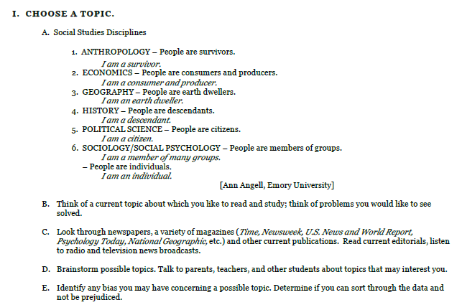

***Sample Topics from Last Year….***

“Social Security: Are Educators and Others Prepared to Fund Their Retirement?”

“I Am Homeless: Where Can I Get Help?”

“Citizenship – Can You Pass the Test?”

“Pricing Trends in the Retail Market”

“What is Ramadan? What Happens in Ramadan and Why?”

“What is Coca-Cola’s History and Economic Impact on Georgia?”

“Protected Species of the Okefenokee Swamp”

“Red, White, and Black Civil War Signals”

“What Did the Hookworm Eradication Program Accomplish Regarding Public Health in the South?

“How Did Sociopolitical Conditions in the Second Half of the Twentieth Century Affect Music?”

“The Soul of the Samurai”

“Teenage Spending”

“Venice, Italy, vs. the Adriatic Sea”

“The Mongols: Civilized or Savage?”

“Why Are There So Many Chinese Girls Who Need to Be Adopted?

“Upgrading Our Future: Are We Technology Dependent?”

“How Can Atlanta Survive Delta’s Failure?”

“What Damage, if any, Is Human Interaction Doing to the Great Barrier Reef?”

“How Did Eleanor Roosevelt Become Known as ‘First Lady of the World’?”

“50 Years After Brown v. Board of Education: Are Our Schools Desegregated?”

“Was the South Justified in Seceding from the Union?”

“How Did Voting Units Affect the 2004 Presidential Elections?”

“Should Auto Insurance for Teen Boys Be More Expensive Than for Teen Girls?”

“NASA Technology – Down to Earth”

“Can Public Schools Offer Fast Food as a Healthy Alternative Lunch?”

“Pet Therapy”

“What Are the Origins of Currency?”

“How Do Storm Chasers Help Save Lives?”

“The Pledge of Allegiance – How Do You Feel?”

“How is Title IX Funding Affecting Men’s and Women’s Sports?”

“What Events Led to Jimmy Carter Winning the Nobel Peace Prize?”

“Origins of Mummification”

“Common Cents: Should the Penny Go?”

“How Many People Can Identify the Continents?”

“What is the True Story Behind the Life and Talents of Blind Tom?”

“How did ‘Black May’ of 1992 Directly Impact the Politics in Thailand?”

“West Nile Virus”

“The Retail Industry: Friend or Foe During the Time of Economic Slowing?”

“Mardi Gras”

“How Successful Have the Land Reform Programs Been in Zimbabwe?”

“World War III: Africa vs. AIDS”

“Magic, Religion and Science”

“The Plight of Sudanese Refugees in Atlanta”

“Returned with Honor – POWs”

**Make a list of things from the above list (or not from the list) that interest you most about social studies…..Consider last year’s Topics and the categories you’re your topic might fit into.** ______________________________________________________________________________________________________________________________________________________________________________________________________________________________________________________________________________________________________________________________________________________________________________________________________

**TOPIC GOTCHAS**

1. Avoid topics that are limited.
   1. Example: What crops are grown in our county?
   2. A student cannot write a report on a topic that can be explained in a few words or a sentence.
   3. Better topic: What is the economic impact of peanut production in our county?
2. Avoid topics that are too broad.
   1. Example: What happened during the Civil War?
   2. Topics which are too big make it impossible to find all the information that is needed to cover the topic adequately.
   3. Better Topic: The Role of (name of a local historical figure, place or event) in the Civil War.
3. Research the topic from a social studies viewpoint rather than investigating it as a natural science topic.
   1. Example: Nuclear power as a political issue rather than "how it works”
   2. “How it Works” would be a Science Fair Project. It Science interests you do a Science Fair Project

**TOPIC APPROVAL SECTION: The topic I (we) have chosen is… Due 10/6**

_________________________________________________________________________________________________________________________________________________________________________________________________________

**Student 1:**

**________________________________ _____________________**

***Parent Signature SS Teacher Signature***

***Student 2:***

**________________________________ _____________________**

***Parent Signature SS Teacher Signature***

**STEP TWO: Create a Research Question–** Coming up with the right question is the first step of any research process. As you narrow down your topic by reading about it, you will begin to have questions that seem important to you. Everything in your paper and on the project board will relate to the answer to the question. So your question needs to be good before you move forward with your research.

EXAMPLES: Why have the Kurds never gotten a country of their own? Why do the Palestinians and Jews keep fighting in Israel? These are questions that could make great Social Studies projects. Maybe you have a strong interest in cooking and you’ve love learning about different styles of food. Have you ever thought about looking into what makes Indian food Indian? Or, maybe “Civil Rights” is your thing. What impact has the shooting death of Michael Brown in Ferguson, MO had on American law enforcement?

* 1. On a separate sheet of paper, list ten questions that deal with your topic. Ask each of these questions about your possible research questions:
     1. Is the topic relevant? Will the answer be of any benefit to you or your community? Ask “so what?” about the question.
     2. Did you avoid questions with “yes” or “no” answers?
     3. Do you already know the answer to the question? (avoid)
     4. Are you biased or prejudiced about the topic?
     5. Will you be able to draw some kind of conclusion to the question?
     6. Can you find information in your community on the topic?
     7. Can you do original research on the topic? (preferable)
  2. Narrow your list of questions to three & discuss the questions with parents, teachers, and friends.
  3. Choose the best research question.

**QUESTION APPROVAL SECTION: The question I (we) have chosen is… Due 10/6**

**__________________________________________________________________________________________________________________________________________________________**

***Teacher Initials (Student 1): _______* Teacher Initials (Student 2):_____________**

**Teacher Comment or Feedback:**

**____________________________________________________________________________________________________________________________________________________________________________________________________________________________________________________________________________________________________________________________________________________________________________________________________________________________________________________________________________________________________________________________________________________________________________________________________________**

**STEP THREE: Establish your Methodology –**

**Due 10/12 (early bird) or 11/2 (late bird)**

Methodology includes the steps in gathering, analyzing, and interpreting the data used to answer your research question. Methodology should include a variety of resources. *One method of research must be original. (Survey, Interview, etc).* Your methodology does not include the steps you take in writing the paper or constructing the display.

Your research methodology must be reported in the paper and on the project board.

Attach a copy of your methodology to this packet.

*BELOW IS A SAMPLE METHODOLOGY*



**STEP FOUR Notes and Outline: Collect, Analyze and Interpret the Data –**

This is done at the same time as your methodology.

Gather articles about your research question.

* Go to GALILEO and find articles that will help you find answers.
* Read the articles and think about what they say.
* Annotate the articles.
* You should discover information that leads you to more articles.
* Take notes and make an outline that leads to a conclusion.
* Charts, tables and other graphic organizers may be used to record information in a form that clarifies how you reach your conclusion (answer to the question).
* Use critical thinking processes to interpret the data and make inferences that lead to a conclusion. Here is how you can find an article on your topic AND save the Bibliography info at the same time.

HOW TO FIND AND USE GALILEO in SUTTON HELPFUL WEBSITES

1. The 4th helpful website link is “Galileo”. The password (8-21-14) for Galileo is… \***reptile**\*
2. Click on “Teen grades 6-8”
3. Click on “Social Studies”
4. Mrs. Marsh’s very favorite DATABASE is called **SIRS DISCOVERER**
5. **Type in “IRAN” (or whatever your topic is) in the search box**
6. **877 articles on IRAN (SIRS cuts to the chase, gives you articles that are “reliable”)**
7. **Click on and article and read to see if you think it will help you answer your question.**
8. **Take notes on your article. Write down the title of the article and the author.**
9. **Now let’s “Cite” the information of this article (so that when we write a paper, readers will know where the information came from**
10. **SCROLL TO BOTTOM where there is a box that says “Citation”**
11. **Copy the information to the right of MLA (the MLA is on letter on top of the other) This is the authors name, article title, publication, volume, data base, date etc.**
12. **Paste this “citation” somewhere (email, word doc, mybackpack doc) and save it**
13. **You have now “collected” and “analyzed” and “Cited” a resource.** Plus, you have also started your bibliography using MLA style. How cool is that?!!
14. **Don’t forget to save the article by emailing it to yourself.**

**STEP FIVE: Write the Summary Paper –**

When a sufficient amount of information to reach a conclusion has been analyzed and interpreted, the student should write a draft of the research paper.

Your paper should be…

* 4 to 5 typed, double-spaced pages using Times New Roman font.
* It should also include a title page with credits, the paper itself, a bibliography, and a credits page.
* It should be neatly bound in a folder.
* The main purpose of your paper is to use facts gained from research to answer your question.
  + These facts should be in your own words and should not be copied from any of your sources.
  + Any idea that is not your own should be properly “cited.”

1. **Title Page/ Cover Page -** The title/cover page should be bound in a folder which clearly presents the name of the project, student name, school name, grade level, and the name of your teacher.
2. **Verification & Credit Page -** The credit page will include the names of people who helped you with your project. This can include names of your family members, along with anyone you talked to about your topic. The credit page should be in complete sentences in a paragraph form. You must also state how each person helped you. A list of names will not be accepted. Also, if your paper was typed by anyone other than yourself, you must include the following at the bottom of your credits page.



1. **Body of Paper** (4-5 double-spaced typed pages)
   * 1. The **Statement of the research question/problem being explored** clearly states why the research topic was chosen.
     2. The **Methodology** explains the steps in the research process—how data was systematically collected and analyzed.
     3. The **Research findings** include adequate and balanced information in a sequential and convincing manner. Include the facts you found and information in a logical order that explains your research findings. Any idea that is not your own should be properly cited.
     4. The **Conclusion** presents a summary of the key idea and answers the question being explored. Your conclusion should be a paragraph (or paragraphs) that include facts from your research and it should be at the end of your paper. You will also need a separate copy of just the conclusion for your backboard.
     5. **Bibliography** - A bibliography page is a list of the resources you used in order to complete your research paper. You must have at least 3 sources and only one may be an encyclopedia. Arrange the list of resources into ABC order according to the author’s last name. If the author is unknown, use the name of the book or title of the article.

**STEP SIX Write the Abstract** –

the Abstract should be written on an index card after the paper is completed, will be given to the judges by the student to use as an overview at the beginning of the interview.

Information on the abstract provides a succinct description of the project, including the title, statement of problem or question, methodology, and conclusion.

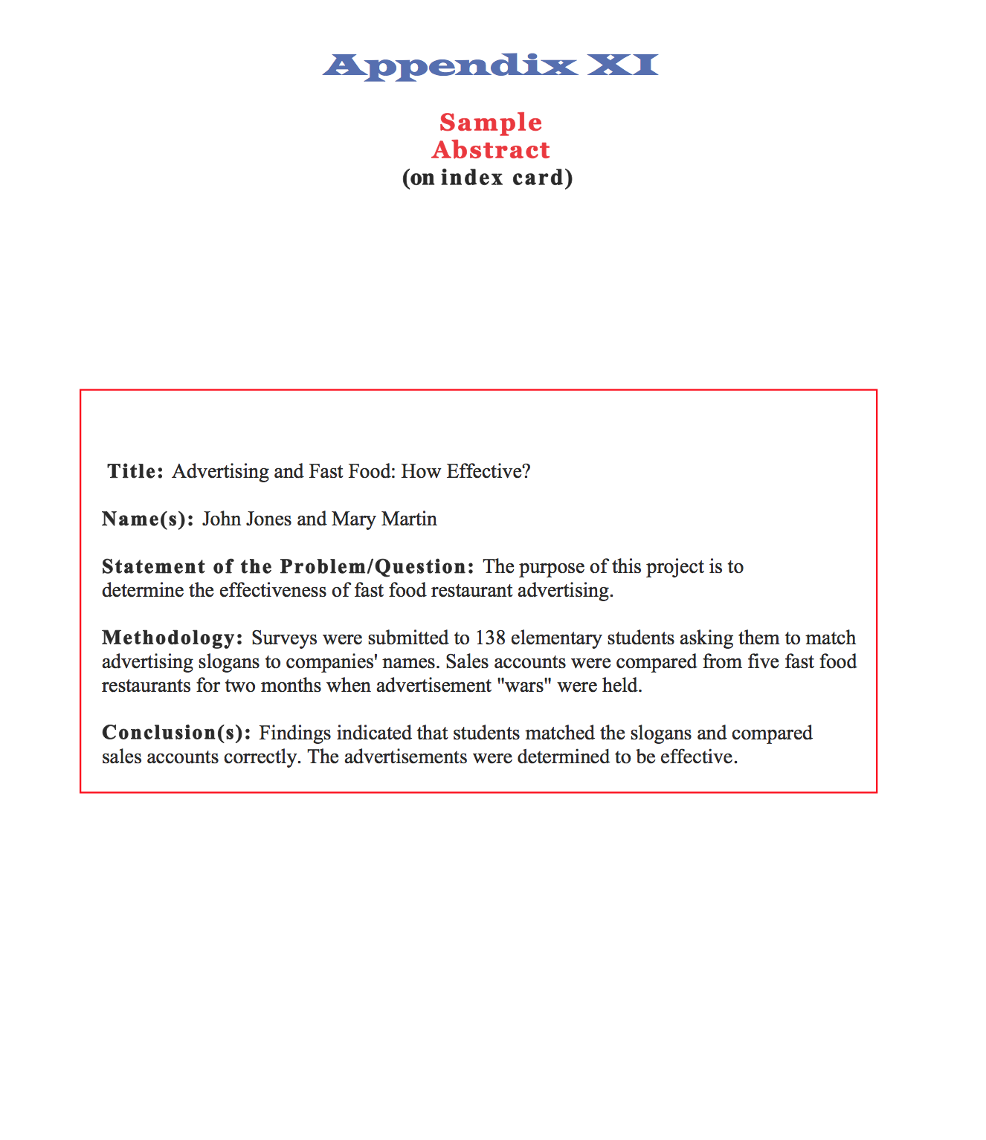

**STEP SEVEN Construct the Visual Presentation –**

Here is a sketch of what your board could look like…

TITLE: CAN BE IN QUESTION FORM

CONCLUSION(S)

VISUALS: Organize photos, graphs and tables carefully to ensure that only data relevant to answering your question is shown.

PURPOSE

The exact same conclusion from your paper needs to be on this side of your project. This is the ONLY part of your paper you put on the project board.

All Headings like “Purpose” “Methodology” and “Conclusions” should be BIG BIG BIG so that they stand out.

METHODOLOGY

VISUALS: Organize photos, graphs and tables carefully to ensure that only data relevant to answering your question is shown.

VISUALS: Organize photos, graphs and tables carefully to ensure that only data relevant to answering your question is shown.

VISUALS: Organize photos, graphs and tables carefully to ensure that only data relevant to answering your question is shown.

(ABSTRACT)

Paper

(in Folder)

(Include Visuals that illustrate or enhance the research findings) Avoid materials that do not relate to the answer to the research question.

**IMPORTANT NOTE:**

**PURPOSE** (the purpose should be a short paragraph explaining your reason or reasons for doing your project)

____________________________________________________________________________________________________________________________________________________________________________________________________________________________________________________________________________________________________________________________________________________________________________________________________________________________________________________________________________________________________________________________________________________________________________________________________________

Teachers and other adults talented in visual display development may be enlisted to coach students in developing the best layout for their information. It is a good idea to have students submit a draft of their proposed layout for suggestions before beginning to work on the display and to check the use of space before attaching any items to the board. If models are used in the display, they should be student designed and constructed, rather than commercially prepared.

**STEP EIGHT Prepare for the Interview –**

Students may prepare for the interview by having teachers or parents practice with them.

Students should be able to give a brief overview of the development of their project and should be prepared to answer questions about importance of their research question/problem, methodology, sources, research findings, and conclusion.

Often judges will ask students to explain their reasons for choosing the topic, to evaluate their work (suggest what might be done differently or additionally if the student were to do the project again), or to recommend what next steps could or should be taken regarding the topic.

Teachers, students, and other supporting adults should refer to the Judges’ Scoring Sheet to review judging criteria related to the interview before, during, and following this step.

***Ask your teacher for a copy of the Judges’ Scoring Sheet.***