Words of the Week (W.O.W.)
Vocabulary Flashcards
Week 2
Directions: Use the format that we discussed in class to write the following words on Frayer Model template. You must include: the word, definition, characteristics, a picture/cartoon/formula, and synonyms/examples and antonyms/non-examples for each word. You will have a quiz over these vocabulary words on Tuesday.
- Trade barriers- ways of limiting trade by tariffs, quotas, or embargos.
- Embargo – A government order stopping trade with another country to put pressure on the government of that other country.
- Quota – A limit placed on the number of imports that may enter a country.
- Specialization – The division of labor; work is divided into parts for workers, factories, or countries to become experts on producing certain goods.
- Tariff – A tax on imports.
- Imports- goods purchased from other countries.
- Exports-goods sold to other countries.
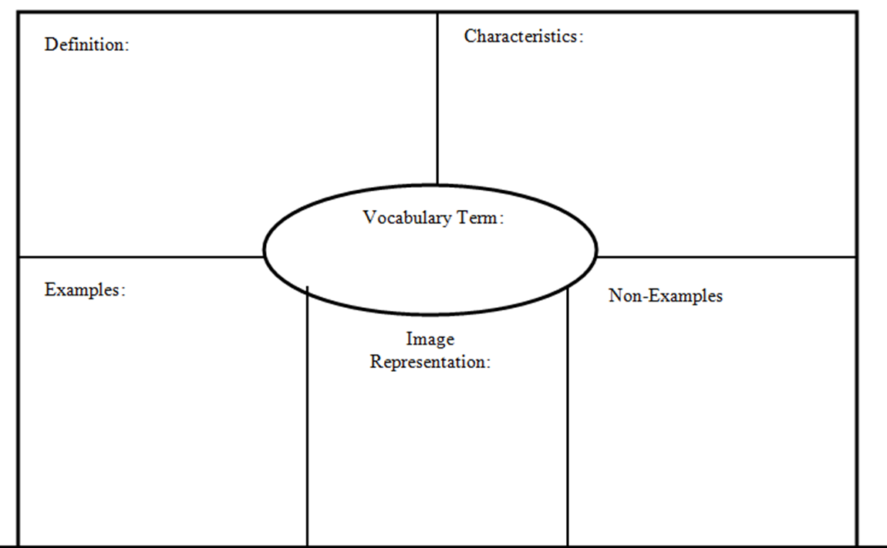
A government order stopping trade with another country to put pressure on the government of that other country.
- Tariff
- Quota
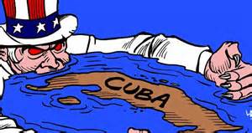
- Ban
- Stoppage
- Prohibit

Embargo
The U.S. placed a stop trade (embargo) on Cuba

