Words of the Week (W.O.W.)
Vocabulary
Week 3
Directions: Use the format that we discussed in class to write the following words on Frayer Model template. You must include: the word, definition, characteristics, a picture/cartoon/formula, and synonyms/examples and antonyms/non-examples for each word. You will have a quiz over these vocabulary words on Tuesday.
1. Capital - Wealth available for or capable of use in the production of further wealth.
2. Gross domestic product (GDP) – The total value of all goods and services produced in a country in one year.
3. Human capital – Workers of a business or country including their education, training, skills and health.
4. Natural Resource – Something that is found in nature and is necessary or useful to humans.
5. Income-money coming in for a person into a business.
6. profit- money left after a business expenses are subtracted from business income.
7. Analyze- to examine carefully and in detail so as to identify causes, key factors, possible results, etc.

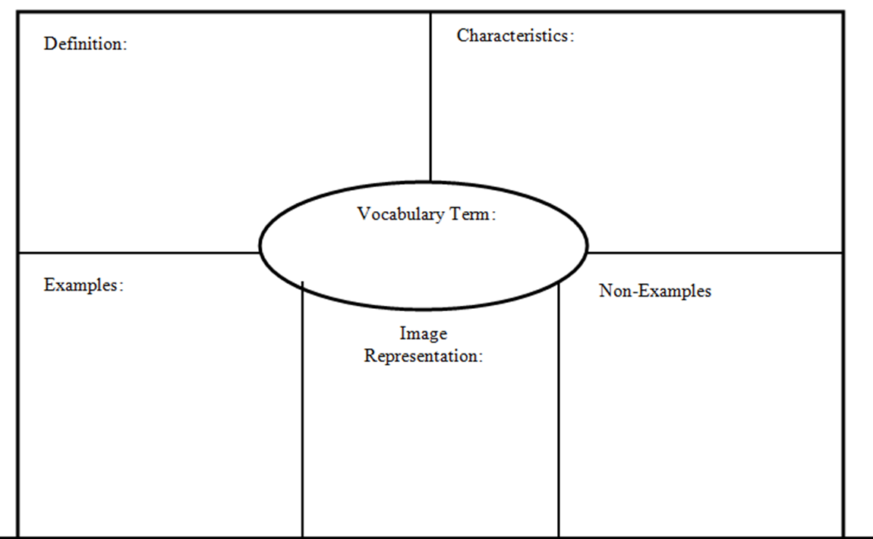
Embargo
- Tariff
- Quota
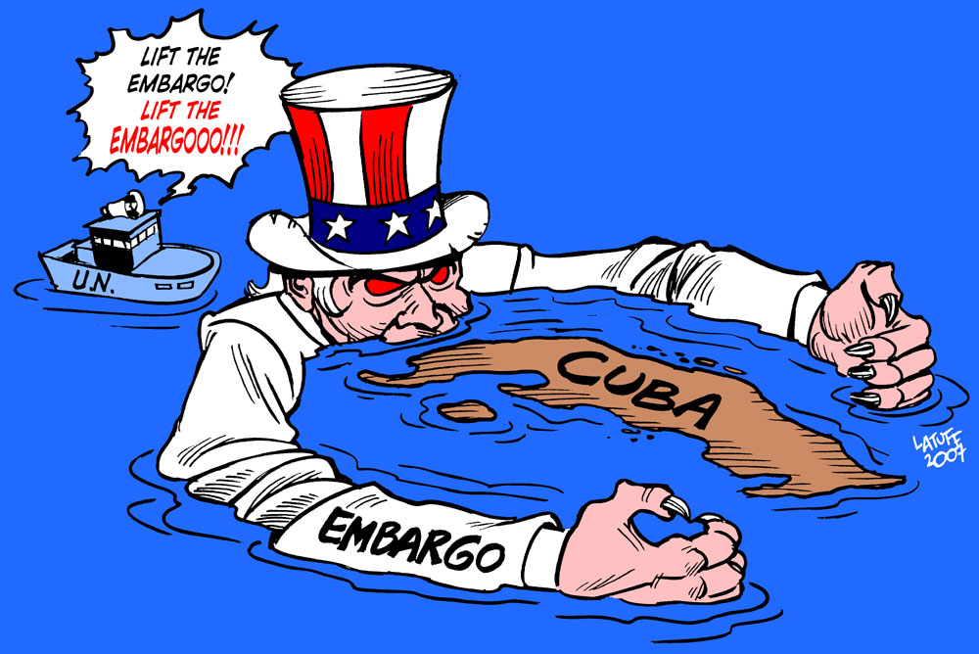
- Ban
- Stoppage
- Prohibit

The U.S. placed a stop trade (embargo) on Cuba
A government order stopping trade with another country to put pressure on the government of that other country.

