Words of the Week (W.O.W.)
Vocabulary
Week 5
Directions: Use the format that we discussed in class to write the following words on Frayer Model template. You must include: the word, definition, characteristics, a picture/cartoon/formula, and synonyms/examples and antonyms/non-examples for each word. You will have a quiz over these vocabulary words on Tuesday.
- Government- a branch or service of the supreme authority of a state or nation, taken as representing the whole.
- Confederation – (power distribution) A form of government based on a voluntary agreement under which separate countries work together.
- Federal – (power distribution) A form of government in which power is divided between a central government and small divisions, such as states.
- Unitary – (power distribution) A form of government in which a central government operates all levels of government in a country.
- Describe: give an account in words of (someone or something), including all the relevant characteristics, qualities, or events.

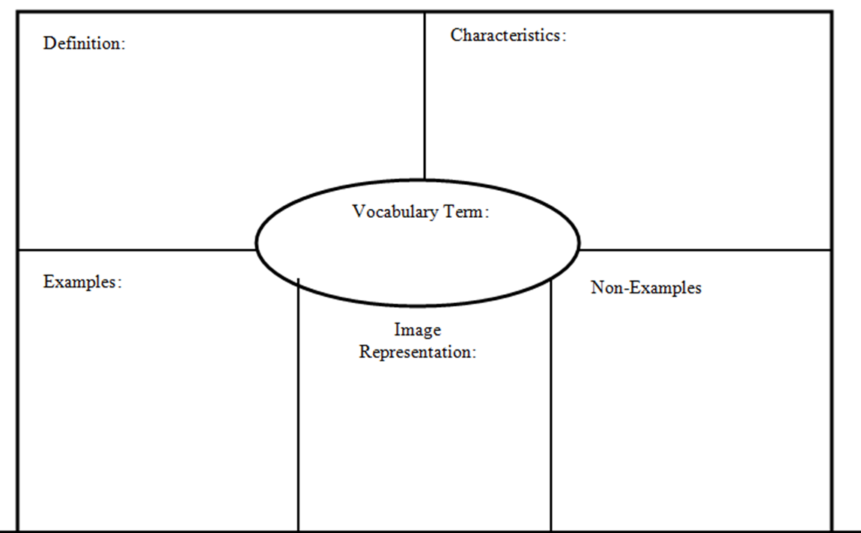
Embargo
- Tariff
- Quota
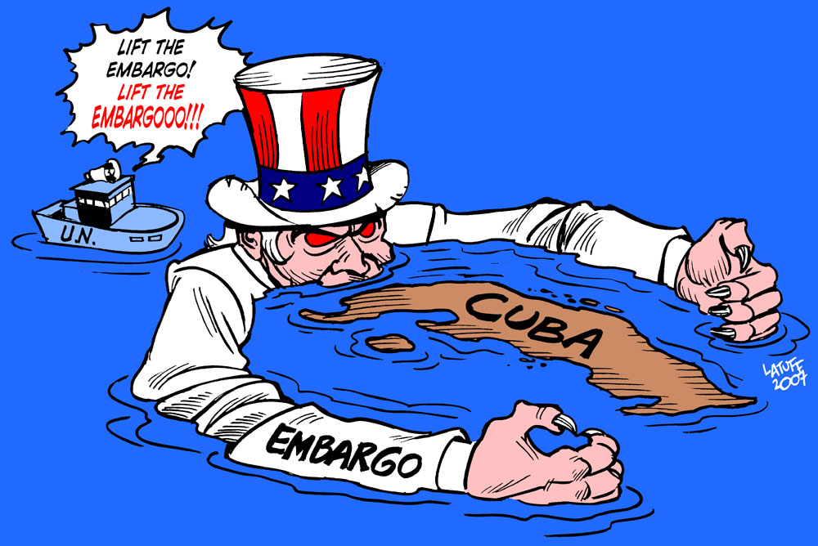
- Ban
- Stoppage
- Prohibit

The U.S. placed a stop trade (embargo) on Cuba
A government order stopping trade with another country to put pressure on the government of that other country.

