Words of the Week (W.O.W.)
Vocabulary
Week 8
Directions: Use the format that we discussed in class to write the following words on your one choice from the Vocabulary Choice Board. You will have a quiz over these vocabulary words on Tuesday.
- Atahualpa – The last ruler of the Inca Empire.
- Aztec – An ancient civilization located in central and southern Mexico.
- Columbian Exchange – The moving of plants, animals and diseases between the Old and New Worlds.
- Conquistador – Spanish conqueror.
- Francisco Pizarro – A Spanish conqueror famous for conquering the Inca Empire.
- Hernan Cortes – A Spanish conqueror famous for conquering the Aztec Empire.
- Inca – An ancient civilization located in located along the coast of South America.
- Indigenous People – The first people known to inhabit an area.
- Montezuma II – The last ruler of the Aztec empire.
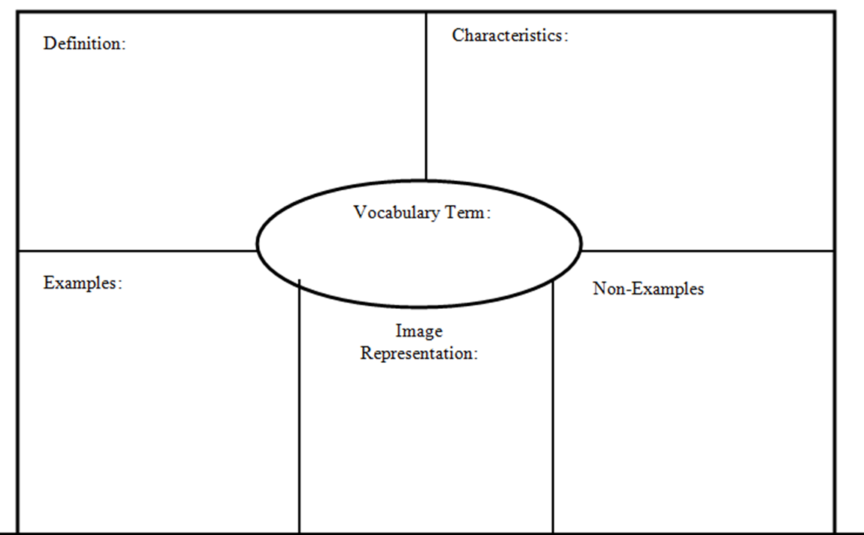
Embargo
- Tariff
- Quota
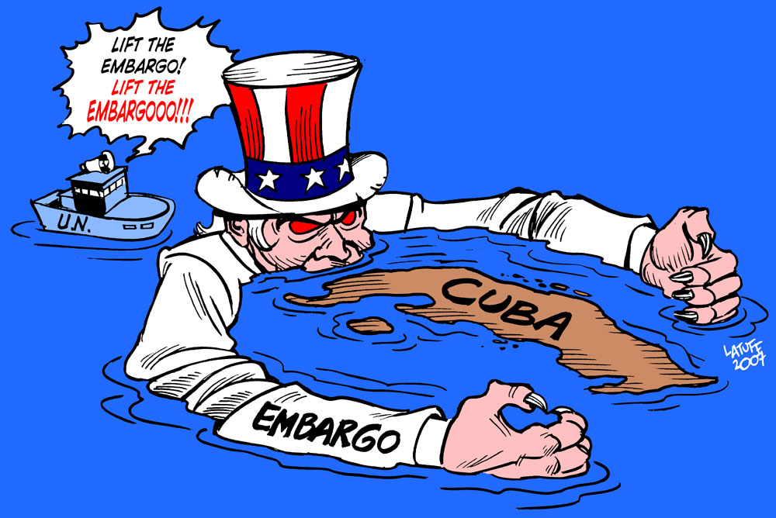
- Ban
- Stoppage
- Prohibit

The U.S. placed a stop trade (embargo) on Cuba
A government order stopping trade with another country to put pressure on the government of that other country.

