Words of the Week (W.O.W.)
Vocabulary
Week 9
Directions: Use the format that we discussed in class to write the following words on your one choice from the Vocabulary Choice Board. You will have a quiz over these vocabulary words on Tuesday.
- Triangle Trade - A system in which slaves, crops, and manufactures were traded between Africa, the Caribbean, and the American colonies.
- Christianity-is a monotheistic (one god) religion based on the life and teachings of Jesus Christ. It is the world's largest religion.
- Catholic – A branch or section of Christianity.
- Ethnic group - a people sharing a common and distinctive culture, religion, language.
- Mestizo – An ethnic group whose ancestors were both European and Native American.
- Mulatto – An ethnic group whose ancestors were both African and European.
- Miguel Hidalgo – Mexican priest who led the country to independence from the Spanish. Known as the Father of Mexican Independence.
- Simon Bolivar – South American soldier who helped many countries gain independence from the Spanish; founded Bolivia in 1825. Known as the George Washington of South American and the El Libertador.
- Toussaint L’Ouverture – A Haitian slave who led a slave revolt against the French and helped to create the new country of Haiti.
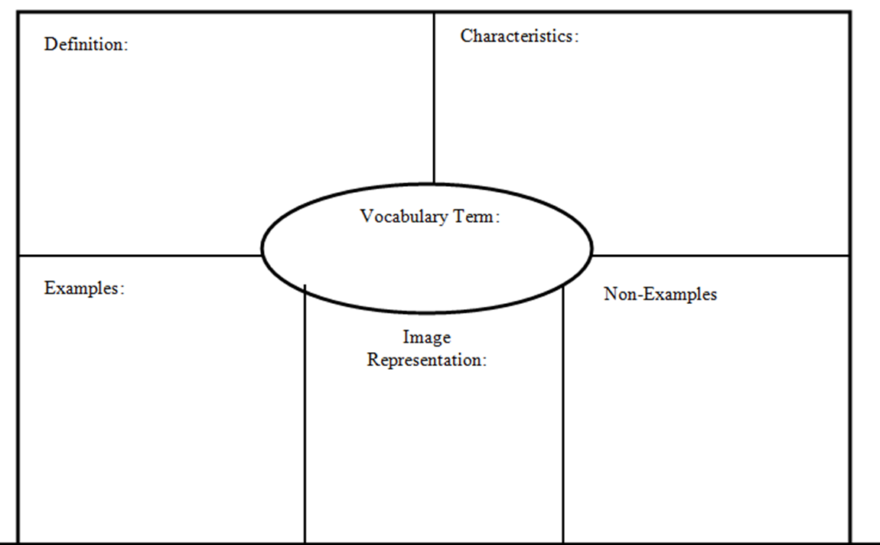
Embargo
- Tariff
- Quota
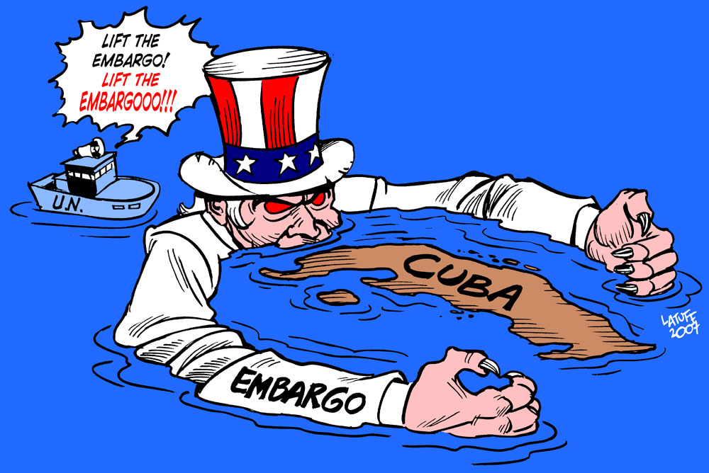
- Ban
- Stoppage
- Prohibit

The U.S. placed a stop trade (embargo) on Cuba
A government order stopping trade with another country to put pressure on the government of that other country.

